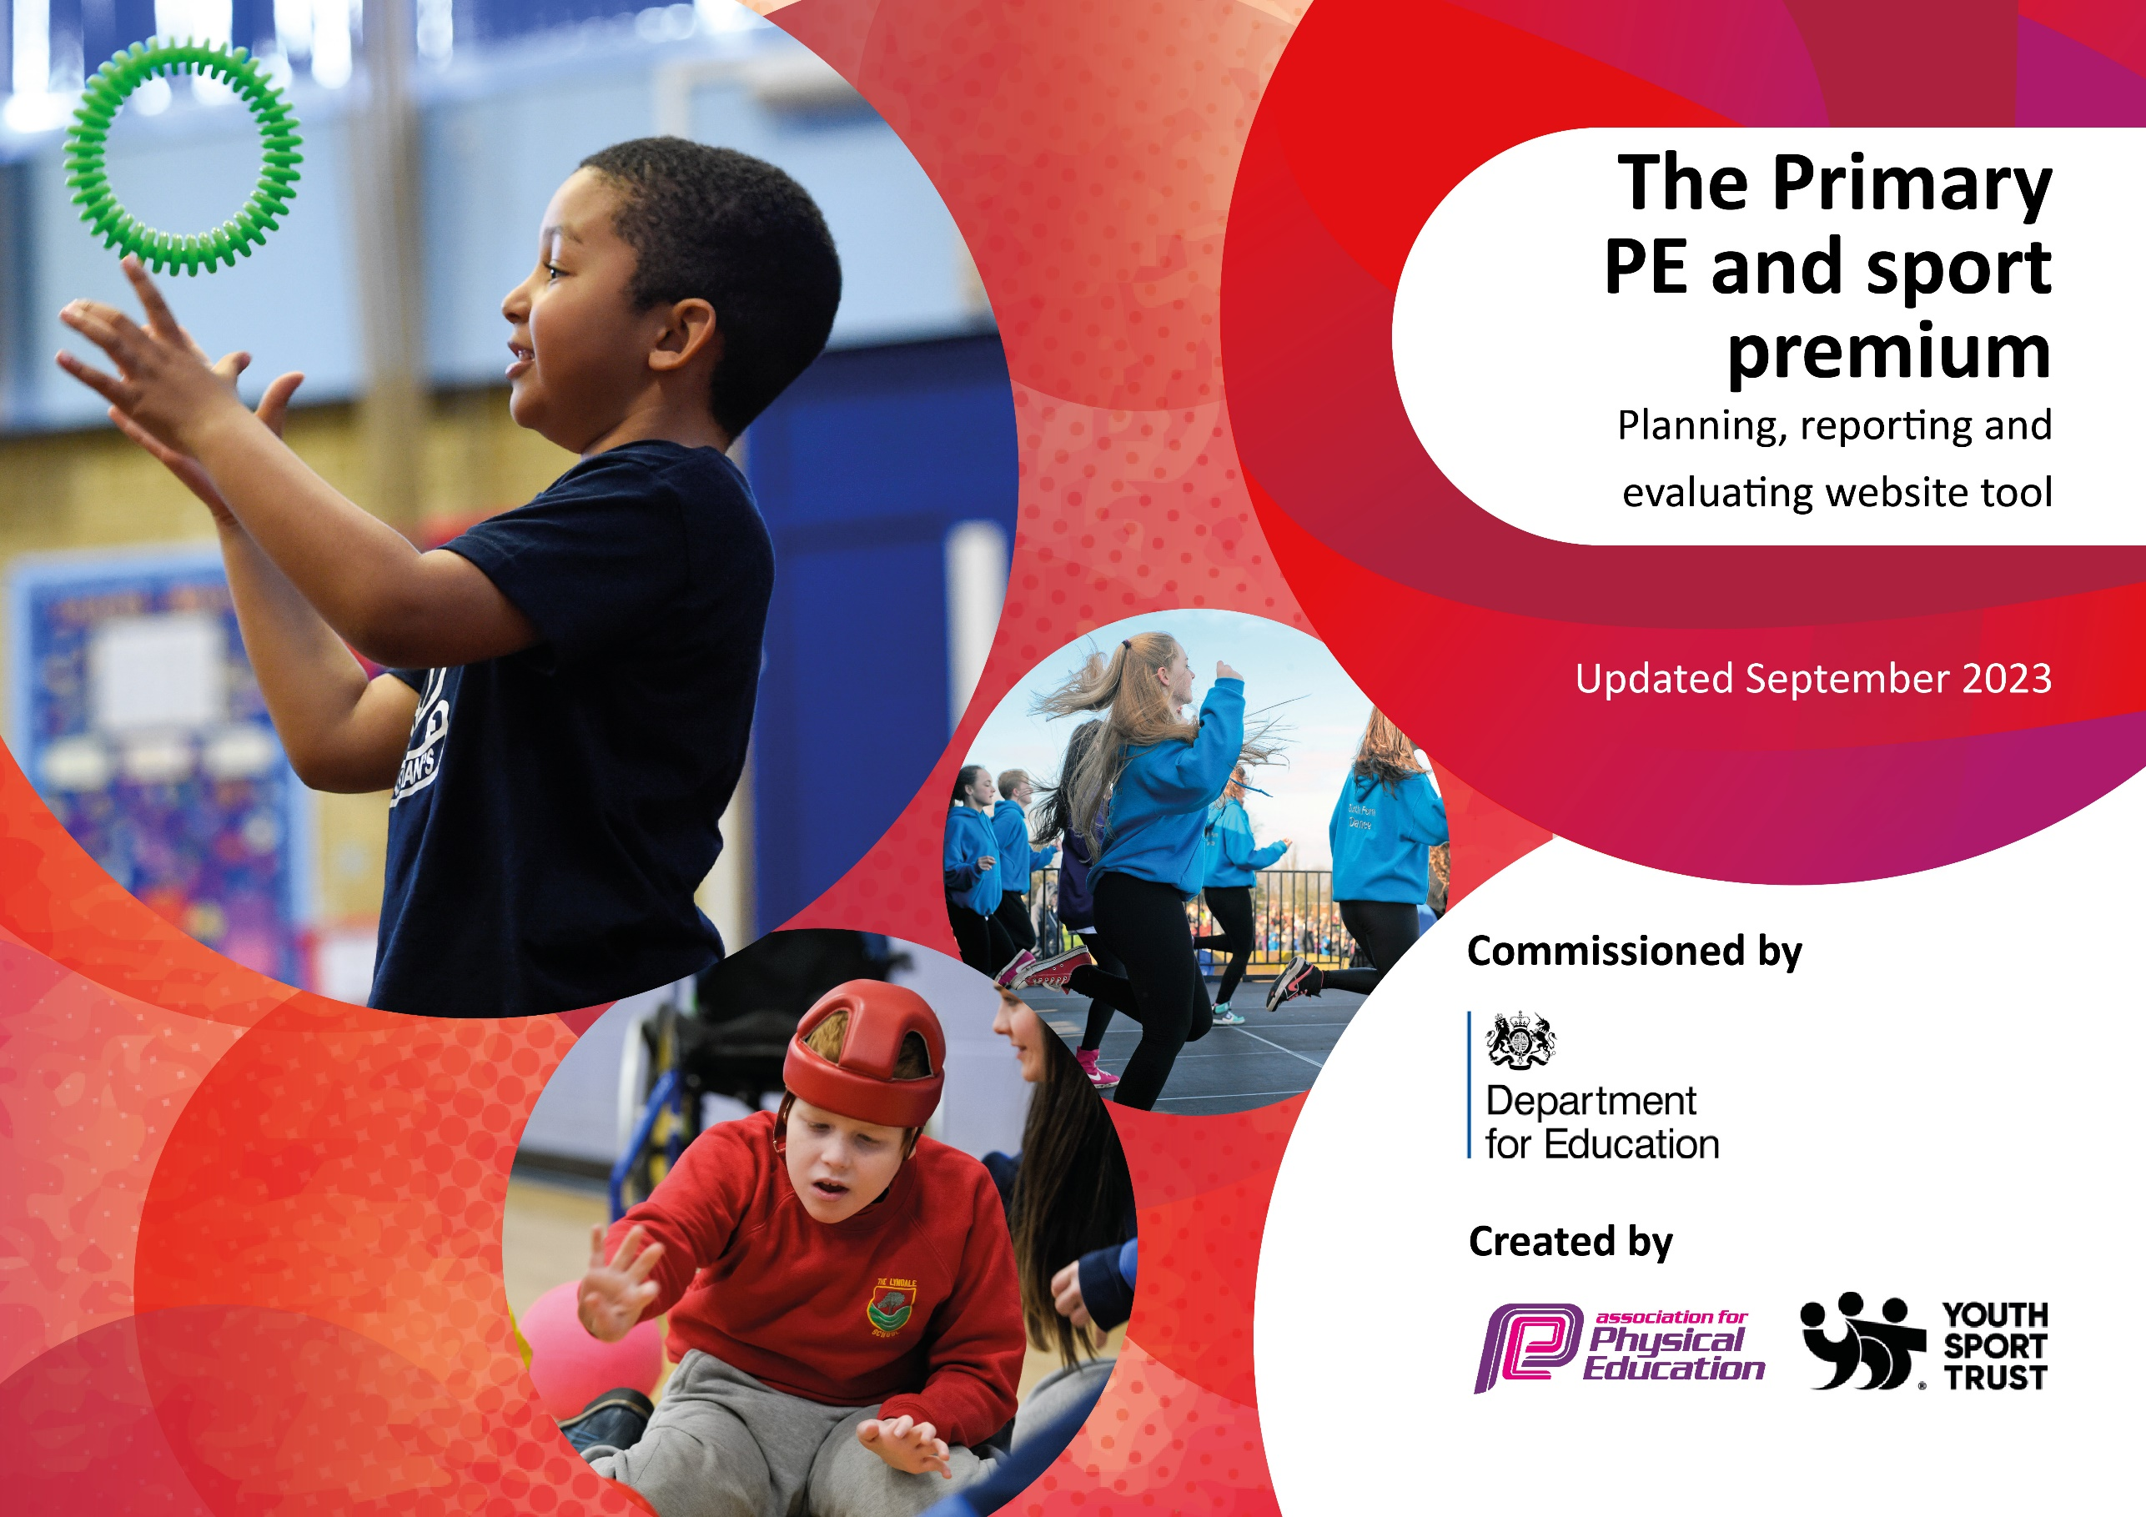

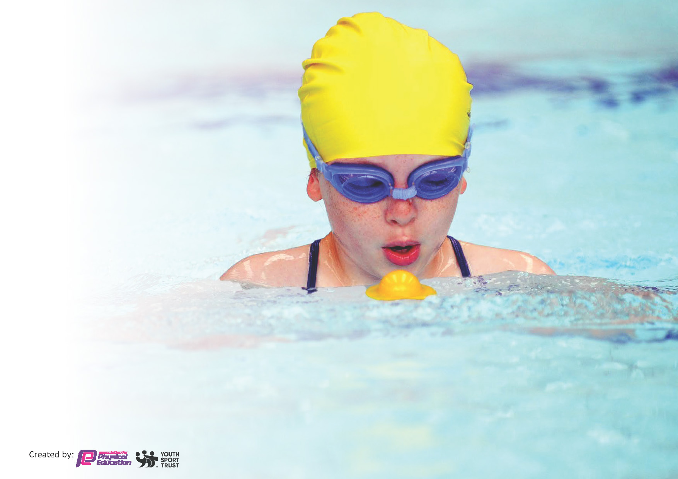
This template can be used for multiple purposes:
by:
- It enables schools to effectively plan their use of the Primary PE and sport premium
- It helps schools to meet the requirements (as set out in guidance) to publish information on their Primary PE and sport premium
- It will be an effective document to support Ofsted inspections enabling schools to evidence progress in Physical Education (PE) and evidence swimming attainment, which forms part of the PE National Curriculum. We would recommend schools consider
the Intent, Implementation and Impact of any spend, as examined within the Education Inspection Framework.

It is important that your grant is used effectively and based on school need.

Schools must use the funding to make additional and sustainable
improvements to the quality of the PE, School Sport and Physical Activity (PESSPA)
they offer. This means that you should use the Primary PE and sport premium to:

- Build capacity and capability within the school to ensure that improvements made now will benefit pupils joining the school in future years
- Develop or add to the PESSPA activities that your school already offers.

The Primary PE and sport premium should not be used to fund capital spend projects; the school’s core budget should fund these. Further detail on capital expenditure can be found in the updated Primary PE and sport premium guidance.

The Primary PE and sport premium guidance, outlines 5 key priorities that funding should be used towards. It is not

necessary that spending has to meet all the key priorities, you should select the priorities that you aim to use any funding towards.

Although completing this template is not a requirement for schools, schools are required to publish details of how they spend this funding. Schools must also outline what the impact this funding has had on pupils’ PE and sport participation and attainment and how any spending will be sustainable in the future. All funding must be spent by 31st July 2024.

The Department for Education has worked closely with the Association for Physical Education (afPE) and the Youth Sport Trust (YST) to develop this template and encourages schools to use it. This template is an effective way of meeting the reporting requirements of the Primary PE and sport premium.
Review of last year’s spend and key achievements (2022/2023)

We recommend you start by reflecting on the impact of current provision and reviewing your previous spend.

Activity/Action | Impact | Comments
Walk to school bus  Train school as sports leaders  Relax kids specialist confidence support  CPD training in cricket, tennis and dance | Update of walking bus is an average of 30 children daily.  These children are taking part in 15 minutes of exercise everyday before school starts. Equally the impact on other children’s health by removing an average of 20 cars worth of pollution from the school gates daily.  All Y5 children have taken part in providing games and activities for different year groups throughout the school year. Children supported by welfare staff have implemented a range of games from the book of games.  Total of 26 children received specialist support. 100% of the children rated sport and healthy choices as an improvement made through the programme 95% of the children’s teachers found that the children had improved reliance in sport and an improved positive mindset to allow them to overcome issues.  Children received quality teaching from specialist coaches and teachers improved their knowledge and understanding for sustainability of coaching knowledge | Continue next academic year extremely effective  Y6 children to continue this year and to train Y5 children to take over their roles ctreating sustainability.  Children more confident in taking part in sport and benefits their mental well being. This will be rolled out to more children in 2023 – 2024  Focus on other teachers and classes in 2023 - 2024

Key priorities and Planning
This planning template will allow schools to accurately plan their spending.

Action – what are you planning to do | Who does this action impact? | Key indicator to meet | Impacts and how sustainability will be achieved? | Cost linked to the action
Continue to develop lunchtime sport sessions/activities for pupils.  Provide range of unstructured fitness opportunities at lunch and breaktimes  Continue to provide a walking bus every day for children to walk to school to increase their daily exercise | Lunchtime supervisors / teaching staff, coaches - as they need to lead the activity  pupils – as they will take part.  Pupils – as they take part in using equipment  Walking bus supervisors, as they need to be at bus drop off point at 8:15  Pupils as they will take part | Key indicator 2 -The engagement of all pupils in regular physical activity – the Chief Medical Officer guidelines recommend that all children and young people aged 5 to 18 engage in at least 60 minutes of physical activity per day, of which 30 minutes should be in school.  Key indicator 4: Broader experience of a range of sports and activities offered to all pupils.  Key indicator 2 -The engagement of all pupils in regular physical activity – the Chief Medical Officer guidelines recommend that all children and young people aged 5 to 18 engage in at least 60 minutes of physical activity per day, of which 30 minutes should be in school.  Key indicator 4: Broader experience of a range of sports and activities offered to all pupils.  Key indicator 2 -The engagement of all pupils in regular physical activity – the Chief Medical Officer guidelines recommend that all children and young people aged 5 to 18 engage in at least 60 minutes of physical activity per day, of which 30 minutes should be in school. | More pupils meeting their daily physical activity goal, more pupils encouraged to take part in PE and Sport Activities.  More children develop independent skills of scootering, woggle boarding and cycling. More children meeting their daily physical needs  More pupils will increase and meet their daily exercise by walking a mile to school every day. | £500 training costs for additional coaches to support lunchtime sessions.  £3300 additional Welfare staff to be employed to supervise and run sports activities  £1000 for additional equipment  £2000 costs for Assistant teachers to run the bus to support lunchtime sessions.

CPD for teachers provided by South Ribble  To improve the uptake of children taking part in competitive sport  Children to experience different sports  Develop wellbeing opportunities to ensure children take healthy lifestyle choices in order that they remain mentally sound. | Primary generalist teachers.  Pupils as they will take part  Primary generalist teachers as they will experience  Pupils as they will take part  Primary generalist teachers as they will experience  Pupils as they will take part | Key Indicator 1: Increased confidence, knowledge, and skills of all staff in teaching PE and sport.  Key indicator 5: Increased participation in competitive sport.  Key Indicator 1: Increased confidence, knowledge, and skills of all staff in teaching PE and sport.  Key indicator 5: Increased participation in competitive sport.  Key Indicator 1: Increased confidence, knowledge, and skills of all staff in teaching PE and sport.  Key indicator 3: raising the profile of PE and sport across the school, to support whole school improvement  Key indicator 4: offer a broader and more equal experience of a range of sports and physical activities to all pupils  Key indicator 2: increasing engagement of all pupils in regular physical activity and sport  333333333: raising the profile of PE and sport across the school, to support whole school improvement | Primary teachers more confident to deliver effective PE supporting pupils to undertake extra activities inside and outside of school, including teaching and as a result improved % of pupil’s attainment in PE  Children will be able to demonstrate their skills and gain experience of competitive sport in a range of different sports against local schools in events organised by South Ribble Sports Partnership. In 12 different sports across a range of age groups.  Specialist coaches will deliver a whole school event in Basketball and athletics festivals  3 classes of pupil’s will be taught tennis by a specialist coach for 5 weeks  Specialist dance coach  Relax kids interventions with children who are anxious in relation to sport and improve general wellbeing and educate about healthy living and to encourage them to actively take part in sport and PE | £1000 for 7 teachers to undertake CPD.  £3000 paid to the Sports School partnership for organising events.  £1000 paid to the Sports School partnership for organising events.  Cost of specialist dance coach  £2500  Specialist Relax Kids teacher to take individuals or small groups.  £8000

Key achievements 2023-2024
This template will be completed at the end of the academic year and will showcase the key achievements schools have made with their Primary PE and sport premium spending.

Activity/Action | Impact | Comments

Swimming Data
Meeting National Curriculum requirements for swimming and water safety.
Priority should always be given to ensuring that pupils can perform safe self-rescue even if they do not fully meet the first two requirements of the National Curriculum programme of study

Question | Stats: | Further context  Relative to local challenges
What percentage of your current Year 6 cohort can swim competently, confidently and proficiently over a distance of at least 25 metres? | % | Use this text box to give further context behind the percentage.  e.g., 30% - we are struggling to get pool space due to our local pool closing so we have had to use a much smaller local school pool. We have had to limit the number of pupils attending swimming lessons during one term which means some pupils have attended fewer swimming lessons than others.
What percentage of your current Year 6 cohort can use a range of strokes effectively [for example, front crawl, backstroke, and breaststroke]? | % | Use this text box to give further context behind the percentage.  e.g., Even though your pupils may swim in another year please report on their attainment on leaving primary school at the end of the summer term 2024

What percentage of your current Year 6 cohort are able to perform safe self-rescue in different water-based situations? | % | Use this text box to give further context behind the percentage.
If your schools swimming data is below national expectation, you can choose to use the Primary PE and sport premium to provide additional top-up sessions for those pupils that did not meet National Curriculum  requirements after the completion of core lessons. Have you done this? | Yes/No
Have you provided CPD to improve the knowledge and confidence of staff to be able to teach swimming and water safety? | Yes/No

Signed off by:

Head Teacher: | (Name)
Subject Leader or the individual responsible for the Primary PE and sport premium: | (Name and Job Title)
Governor: | (Name and Role)
Date:

