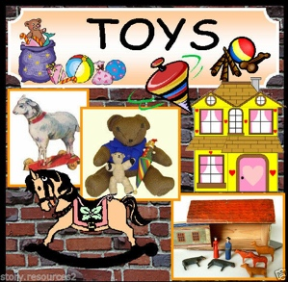

Has today’s visit to the Harris Museum and Art Gallery inspired you to want to find out more about Toys?

Here are some fiction and non- fiction books that you might like to read. You may be able to borrow them from your local Library. Visit https://www.lancashire.gov.uk/libraries-and-archives/libraries/ for more information about your local library services.
Tottie, the story of a Doll’s House – Rumer Godden

Tottie is a loving little wooden doll who lives with her family in a shoebox. The doll family are owned by two sisters, Emily and Charlotte, and are very happy, except for one thing: they long for a proper home. To their delight, their wish comes true when Emily and Charlotte fix up a Victorian dolls' house - just for them.

Reading Age 9 to 12
Where’s My teddy? – Jez Alborough

Eddy's lost his teddy, Freddy. So off the goes to the wood to find him. But the woods is dark and horrible and little Eddy is in for a gigantic surprise!

Reading Age Up to 4

Dogger – Shirley Hughes

When Dave loses his favourite toy, Dogger, he is desolate. But then Dogger turns up at the school summer fair, and everything seems all right - until someone else buys him before Dave can get the money!

Reading Age 3+

This is the Bear – Sarah Hayes

This is a story told in rhyming verse about a boy, the bear and a dog who are the best of friends. But one day the bear gets lost and has to be searched for high and low.

Reading Age 3 to 5

Lost in the toy Museum – David Lucas

Join the adventure when the lights go out in the toy museum! One night, when the lights go out at the toy museum, everyone runs off and hides. Left all on his own, Bunting, the sensible old toy cat, sets out to look for them.
Reading Age 5+

Toys From the Past – Joanna Brundle

Did you know that the first teddy bear was made in 1902? Teddy bears are named after the U.S. president Teddy Roosevelt. Find out more in Toys from the Past.

Reading Age 4 to 8

The Boy with the Bronze Axe- Kathleen Fidler
Exploring the variety of toys and games that children have played with over the last 100 years, this book makes comparisons between today's toys and those of the past.

Reading Age 5+

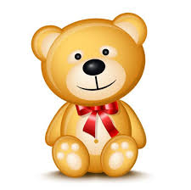
READING IS SO MUCH FUN!
Just Like Jasper – Nick Butterworth

Help Jasper to choose how to spend his birthday money. Jasper plays with just about everything in the toyshop. But what will he eventually buy?

Reading Age 6
The Toymaker – Mark Waddell

Mary is too sick to play outside with her friends, so her father makes her three dolls who are just like them; years later, as an old woman, Mary rediscovers the dolls and find that her father's gifts live on.

Reading Age 5+

Reading Age 5+

More great books that you may want to try include:

- Toys in Space by Mini Grey (Reading Age 3+)
- Traction man is Here by Mini Grey (Reading Age 7)
- The Velveteen Rabbit by Margery Williams (Reading Age 6 to 10)
- In The past Toys by Dereen Taylor (Reading Age 5+)
- Toys in the Past by Joanna Brundle (Reading Age 5 to 6)

