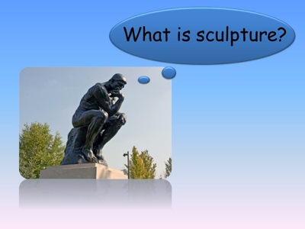 What is Sculpture?

Has today’s visit to the Harris Museum and Art Gallery inspired you to want to find out more about the Stone Age?

Here are some fiction and non- fiction books that you might like to read. You may be able to borrow them from your local Library. Visit https://www.lancashire.gov.uk/libraries-and-archives/libraries/ for more information about your local library services.

Stone Giant: Michelangelo's David and How He Came to Be – Jane Sutcliffe

No one wanted the "giant." The hulking block of marble lay in the work yard, rained on, hacked at, and abandoned—until a young Michelangelo saw his David in it. This is the story of how a neglected, discarded stone became a masterpiece for all time. It is also a story about art—about an artist’s vision and process, and about the ways in which we humans see ourselves reflected in art.

Reading Age 9 to 12

Reading Age 6+

In Mary’s Garden by Tina Kugler and Carson Kugler

While the rest of her classmates were making pastries in cooking classes, Mary Nohl was making art—anything she fancied out of anything she could find. Inspiration struck Mary even when she wasn’t looking for it. Mary used common objects to make uncommon art and one day, her garden became a gallery.

Reading Age 6 to 9

Two Brothers, Four Hands – Jan Greenberg and Sandra Jordan.

The inspiring true story of the Giacometti brothers, one an artist, the other a daredevil, both devoted to their craft but even more devoted to each other. Everyone who knew them agreed. Alberto was the genius of the family. His younger brother Diego was his opposite--he didn't care much for books or schoolwork, and he had no idea what he would be when he grew up. But despite their differences, the two brothers shared an intense bond. Alberto Giacometti became one of the iconic artists of the twentieth century, whose tall, spindly sculptures grace the collections of museums around the world. Diego was always at his side, helping and encouraging, and in his spare time creating remarkable pieces of furniture, works of sculpture in their own right.

Reading Age 7 to 10

Modelling Clay: Animals – Bernadette Cuxart

Follow the instructions to make your very own animal sculptures.

Reading Age 3+
13 Sculptures Children Should Know – Angela Wenzel

This book is full of pictures of the work of some of the world’s greatest artists. You can learn facts about the artists and their work. There are games, quizzes and other activities to help you learn about the significant contributions of each artist in a fun way.
Additional information about museums, suggestions for further reading, and online resources will satisfy the most curious minds.

Reading Age 6 to 9

Reading Age 7+

The Moonlight Statue, The Hounds of Penhallow Book 1

Polly and her mum are leaving London for Cornwall. Their old home has very sad memories after Polly’s father died in an accident. Mum has a new job as house manager at a stately home, Penhallow Hall. They both love it from the start, and the house seems to take to Polly – magically the statue of a huge wolfhound at the hall’s entrance comes to life for her and becomes her friend.

Reading Age 7+

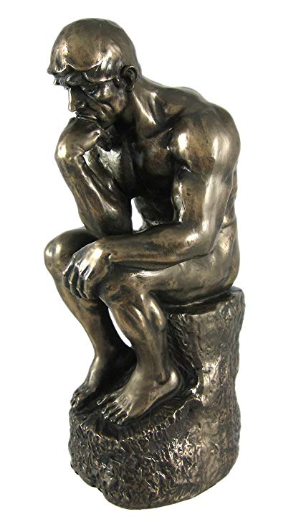
More great books that you may want to try include:

- Sandy’s Circus A Story About Alexander Calder by Tanya Lee Stone and Boris Kulikov (Reading Age 6 to 8)
- Three dimensional Art Adventures by Maja Pitamic, Jill Laidlaw t (Reading Age 6+ )
- Enchantment in the Garden by Shirley Hughes (Reading Age 5 to 7)
- The Little Mermaid by Hans Christian Anderson (Reading Age All ages)
- The Stoneheart Trilogy by Charlie Fletcher (Reading Age 10+)

