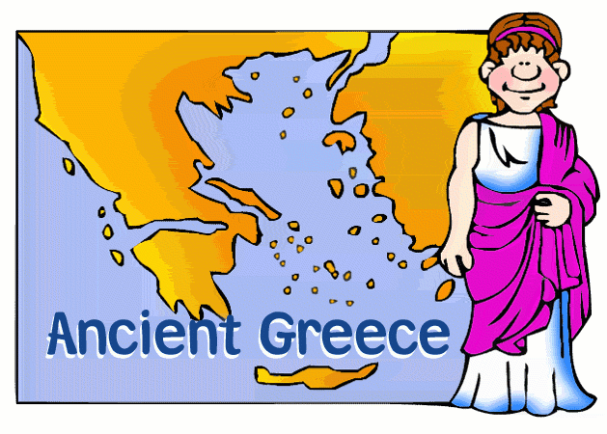

Has today’s visit to the Harris Museum and Art Gallery inspired you to want to find out more about the Ancient Greeks and their myths ?

Here are some fiction and non- fiction books that you might like to read. You may be able to borrow them from your local Library. Visit https://www.lancashire.gov.uk/libraries-and-archives/libraries/ for more information about your local library services.
Who Let the Gods Out? – Maz Evans

This is the story of a boy called Elliot who falls into an adventurous mission and calls on the help of the Olympian gods. It will make you laugh; it will make you sad. An excellent read.

Reading Age 7 to 12

Beasts of Olympus: Beast Keeper – Lucy Coats

This action- packed novel is a page turner. It is a fun introduction to the goddesses and creatures of Greek mythology

Reading Age 10+

The Ancient Greek Mysteries – Saviour Pirotta and Freya Haratas

Fun action -packed stories which follow the adventures of a scribe called Nico and his friend Thrax, who is a slave as they work together to solve mysteries. The stories are set around everyday life in Ancient Greece.

Reading Age 7+

Greek Gods and Heroes – Sylvie Baussier

40 different male and female figures from Greek mythology are introduced in this book. Each character has a double page spread and you will learn about them through bite sized chunks of text, bright illustrations and facts and figures. An amazing way to learn lots of detail and facts.
Reading Age 11+

Hopeless Heroes: Here Comes Hercules! – Stella Tarakson and Nick Roberts

School boy Tom Barker’s life is turned upside down when he accidentally breaks an Ancient Greek vase, unknowingly releasing the mighty god Hercules into the 21st Century. Only Tom can see Hercules as chaos ensues. This is a fast- paced, mischief and mayhem filled story.

Reading Age 9+

Fleeced! – Julia Wills

This is a funny story , an exciting witty adventure where characters from Greek mythology are transported to modern day London.

Reading Age 8

A Visitor’s Guide to Ancient Greece- Lesley Simms

Written like a guidebook for time travellers full of details, images, weblinks and interesting facts. A perfect way to learn more about life in Ancient Greece.

Reading Age 7+

Avoid Entering the Ancient Greek Olympics!
( Danger Zone) – Michael Ford

A humorous cartoon style text with non-fiction features which will provide you with an overview of life in Ancient Greece.

Reading Age 7+

The First Olympics of Ancient Greece – Lisa M. Bolt Simons

In Ancient Greece different city-states often fought one another in deadly battles. But every four years they set aside their differences to honour the gods and compete peacefully on the Olympic Games. Learn all about the athletes, competitions, and religious ceremonies of Ancient Greece.

Reading Age 6 to 8

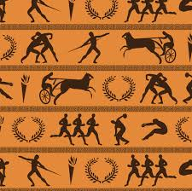
Geography Matters in Ancient Greece – Melanie Waldron

This book will tell you about the crops grown in Ancient Greece, how the city states formed around the Greek empire, the climate, housing and clothing. You can read many more fascinating facts about many aspects of Greek life through its Geography.

Reading Age 8 to 11
Daily Life in Ancient Greece – Don Nardo

This book will let you explore what life was really like for the everyday people in Ancient Greece. It uses primary sources and information from real archaeological discoveries to uncover some fascinating insights. It will make you rethink some of the most popular Greek myths. Reading this book will make you feel like you are on a time- travelling journey.

Reading Age 9 to 11

GREEK MYTHOLOGY
Illustrated Stories from the Greek Myths- Usborne

This book features the best – known of all the Greek heroes and monsters with six stories starring Perseus and Medusa, Pegasus, Heracles, Odysseus, the Wooden Horse and the Minotaur. After you have enjoyed the stories there is a section which gives you more details on Greek Gods and other myths.

Reading Age 6+

Greek Myths and Legends – Anna Claybourne

This book will give you a detailed introduction to the most famous gods and goddesses in Greek mythology and their exploits. It will help you understand the stories of the gods and the way in which they were worshipped.

Reading Age 7+

More Myths

The Tale of Troy by Roger Lancelyn Green
( Reading Age 10+)

Atticus The Storyteller’s 100 Greek Myths by Lucy Coats (Reading Age 8+)

If you like to read online try:

https://www.greekmyths4kids.com/

More great books that you may want to try include:

- The Girl of Ink and Stars by Kiran Milwood Hargrave (Reading Age 11)
- Horrible Histories : Groovy Greeks by Terry Deary (Reading Age 7+)
- The Odyssey by Louie Stowell (Reading Age 7+)
- Wings of Icarus by Jenny Oldfield (Reading Age 7+)
- Make This Greek Temple by Iain Ashman (Reading Age 8+)

