January 2022

Online Safety Newsletter

Smart TV / Streaming services

There are so many TV streaming services available now such as Netflix, Prime, Apple TV, Now TV and Disney as well as more families having Smart TVs, which connect to the internet and allow you to download apps and access YouTube for example. This means our children potentially have access to a lot more content, some of which may not always be appropriate to watch.

If your child does access content through these services then, as always, make sure you set parental controls so they can only view content that is suitable for their age.

Each service will have their own parental control settings with most of them using a Parental PIN so you can restrict what can be viewed (and purchased in some cases).

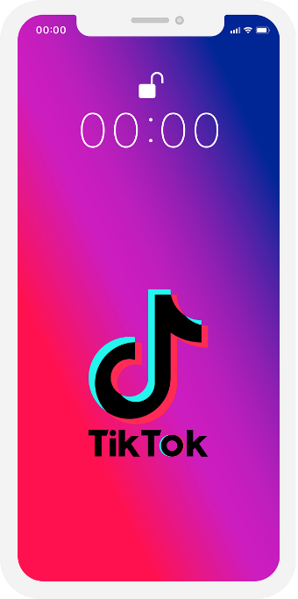
TikTok

You must be over 13 years of age to use TikTok. Users can watch musical clips, record clips (it includes lots of lip synching and dancing), edit them and add special effects.

Why should I be concerned?
You need to be aware that some of the videos may contain explicit language and sexual imagery, which may not be suitable for your child to view. There is also the risk of strangers contacting your child so make sure you have set up the appropriate settings.

If your child is using TikTok then we recommend setting the account as private (this is the default setting for users under 16 since Jan 2021). Even with a private account, your child’s profile information such as their photo and bio are still visible so ensure your child understands the importance of not adding personal information (e.g. location, age and phone numbers) to this area. This article explains how you can strengthen your privacy settings and what features are turned off by default for accounts for children aged 13 – 15: https://newsroom.tiktok.com/en-us/strengthening-privacy-and-safety-for-youth

Family Pairing
This allows parents to link their own TikTok account to their child’s account. This will allow you to set controls such as restricted mode (limit the appearance of inappropriate content) and screen time management (control how long they can spend on TikTok each day). You can find out more here: https://www.tiktok.com/safety/en/guardians-guide/

Challenges and Trends
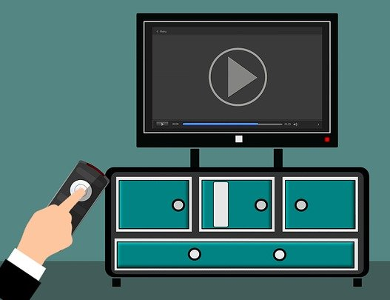
Lots of them are fun and not harmful but sometimes they can be risky. TikTok have produced this resource to help you talk to your child about challenges and the potential risks: https://www.tiktok.com/safety/en-sg/online-challenges/.

Blocking and Reporting
As with similar apps, there is the ability to report and block other users so ensure your child knows how to use these features:
- https://support.tiktok.com/en/safety-hc/report-a-problem
- https://support.tiktok.com/en/using-tiktok/followers-and-following/blocking-the-users
Users of this guide do so at their own discretion. No liability is entered into. Current as of the date released 01.01.22.

An update

BBC Own it keyboard and App

Did you know BBC Own It has a keyboard and app? Download the app on your child’s phone to access the special keyboard, which will offer advice as they type and intervenes for example, if they’re sharing their mobile number, the app will tell your child to ‘think safe’ before they send the message. Find out more here:
https://www.bbc.com/ownit/take-control/own-it-app

BBC Own it also has a dedicated area for you with video guides on useful topics such as ‘the transition from primary to secondary school’ and ‘supporting children with social media apps’ and links to other useful sites. Click below to access:

https://www.bbc.com/ownit/curations/parents
Fortnite
Is your child playing Fortnite? It is rated PEGI 12 for frequent mild violence which means it is not suitable for persons under 12 years of age.

It is important to remember that when rating games, PEGI do not take into consideration the communication features of a game. Fortnite does include a chat facility, which adds further risks.

What is Fortnite?
There are different versions of Fortnite, including a free-to-play Battle Royale game (although money can be spent within the game) where up to 100 players compete against each other.

What do I need to be aware of?
- Chatting to strangers and inappropriate language: Fortnite contains voice and text chat. Due to the nature of the game, your child may be chatting to strangers and may hear inappropriate language. Ensure your child knows how to report players for any inappropriate behaviour.
- In app purchases: All users can purchase V-Bucks directly through the game. This currency can be used to purchase items in the Fortnite store so make sure you don’t store your payment details within the game/device and restrict purchases.

Parental Controls
Apple Guided Access / Android Screen pinning

Does your child use your phone at times? Both Apple and Android give you the ability to restrict what can be accessed when they are using it, so you can restrict your device to the one app that your child would like to use (so all other features are disabled).

Use the following links to find out how to set it up:

Apple:
https://support.apple.com/en-gb/HT202612

Android: https://support.google.com/android/answer/9455138?hl=en-GB

Fortnite includes several parental controls to help you make it a safer environment for your child including disabling voice chat, filtering language and setting privacy settings. Find out more about parental controls here: https://www.epicgames.com/fortnite/en-US/parental-controls. Also, remember to set up age-appropriate parental controls on the device your child is playing on as well.

Further information
https://www.internetmatters.org/parental-controls/gaming-consoles/fortnite-chapter-2-battle-royale-parental-controls-guide/
LEGO Build and Talk

LEGO® have created Build and Talk to help you chat to your child about digital safety and wellbeing. Firstly, you pick an activity to do and then you read a story, which includes questions and conversation prompts, whilst they build with their LEGO®. This is a great way to start talking about online safety with your child! https://www.lego.com/en-gb/sustainability/children/buildandtalk/

Whilst you’re there, view their guides on key topics related to online safety https://www.lego.com/en-gb/sustainability/children/digital-child-safety/ or play Doom the Gloom with your child, which will support them in using the internet safely: https://www.lego.com/en-gb/campaigns/kids/doom-the-gloom.

