This project is all about the Zoo.

Have you ever been to a zoo?
What animals did you see there?
Which was your favourite?

Here you will find lots of suggestions for activities you could do to complete your project.

There will also be links to websites and some activity sheets you might want to use.

Each class/tribe is an animal – you might want to think about those animals within your project.
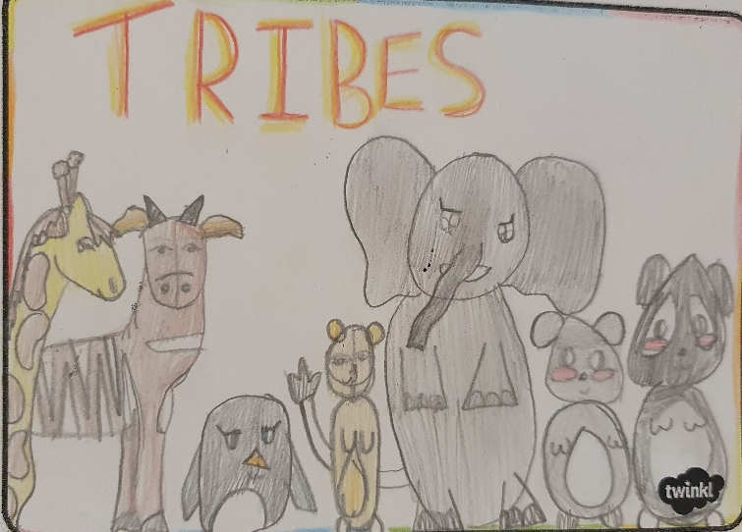

Evie Year 6

WEBSITES
https://www.chesterzoo.org/schools/resources/
There are lots of home learning activities on site.

https://www.marwell.org.uk/education/free-resources/
There you will find activities and information fact files – there is a lot of stuff, e.g. fact files of different animals and where they come from.

https://www.dkfindout.com/uk/more-find-out/special-events/endangered-animals/
all about endangered animas

https://www.bbc.co.uk/bitesize/topics/z6882hv
This will help you find out all about the different groups of animals.

https://www.bbc.co.uk/newsround/52483218
Newsround program about how zoos are managing during lockdown

Here are some ideas of things you could explore, I’m sure you can think of lots more as well.
Find and read books all about animals, they might be non-fiction (information books) or they could be stories with animals in. | Where do animals come from? Find out and label them on a map or cut out pictures of them to stick on. | How can we sort and group animals?  Animals might be birds, mammals, reptiles, amphibians, fish, invertebrate. can you find some which belong to each group?
Choose an animal, can you label the different parts of it? Giraffes have long necks, do you know why? | What to the animals in the zoo eat?  Do the keepers feed them the same as if they were in the wild? | Make an animal costume or mask.
Draw /paint / make models of different zoo animals. | Write a diary of being a zoo keep for the day. | Design your own zoo? what will it be called? where will the animals live? Design a logo for your zoo?
Write information cards for the animal enclosures for people to read as they are walking around. | Find out about endangered animals and what people are doing to help save them from extinction. | Discover an animal which no one has ever seen before. What does it look like? Where does it live? What does it eat? How do you look after it?
What has been difficult for the zoos during lockdown? What have they been worried about? | How much does it cost to feed the animals in a zoo? | How many zoos are in the United Kingdom. Can you find them and mark them on a map?

