My World
Find out all about the world around us…

Find out all about the Earths continents - which is the biggest, smallest, hottest, coldest? Has the highest mountain or waterfall?etc.
Research the seas and oceans – how deep are they? What lives there?

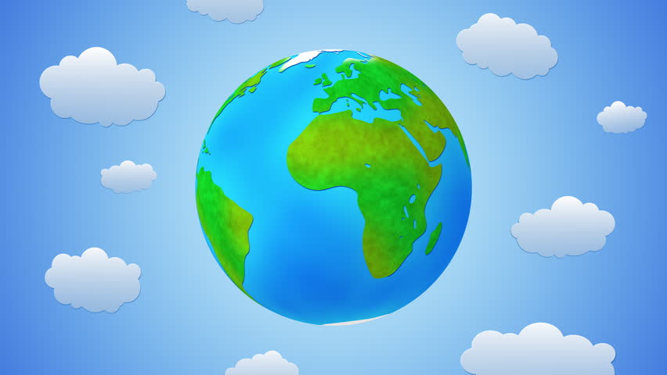

Love volcanoes – where are they in the world? Which are active? Mountains – where are the highest - waterfalls where are the most spectacular?
Look at the rivers around the world, which is the longest, widest, fastest? Why were rivers important for settlers?

More challenges…
Learn about the different flags for each country and what they mean.
Choose a country to research fun facts about – is it hot or cold? Why do people visit? What do people eat?
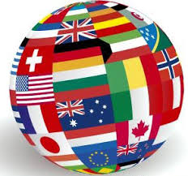
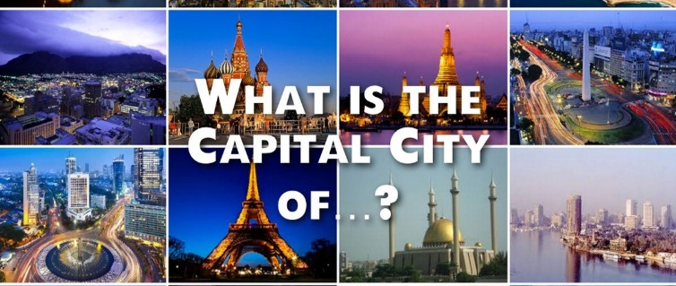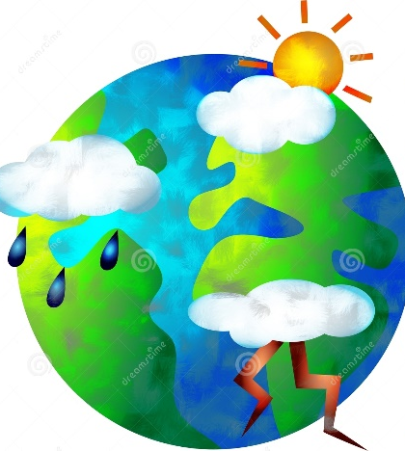
What is the weather like around the world? Which countries have extreme weather – why?
Where are the hot places /cold places -why?

Do you know the capital cites of Europe?
What other capital cities do you know around the world?
Find out more!!!
Useful websites;
https://www.activityvillage.co.uk/around-the-world
https://www.bbc.co.uk/bitesize/subjects/zcdqxnb
https://www.bbc.co.uk/bitesize/topics/zyhp34j
https://www.natgeokids.com/uk/teacher-category/geography/
country! What language will people speak? Will it have a volcano, waterfalls, mountain, rivers? Why will people come to your country? What will they eat what will the flag look like?
ocean – what lives there? How deep is it?
Want a bigger challenge!
Design a whole new world!!!
What shape will it be? How many countries will there be? What seas and oceans etc etc.
Go wild and use your imagination – you could make it 3D or 2D – have fun!
continent – what will it be called? What will it look like?
Looking for a challenge?!
Design your own whole new…
Something different
We all know to reuse, reduce and recycle but what does that actually mean? How can we remind people?
Could you produce a booklet, posters to help people with ideas? What could you do in the community?
Plastic is a big concern across the world – what can you do to highlight this?
Could you make some art out of recyclable materials to show people how much waste we produce?
Useful websites;
https://www.free-for-kids.com/childrens-environment-resources.shtml
https://kids.nationalgeographic.com/explore/nature/kids-vs-plastic/
https://www.theschoolrun.com/homework-help/caring-environment
You will have your own amazing ideas too – look forward to seeing what you come up with!
